HARDWARE SETUP

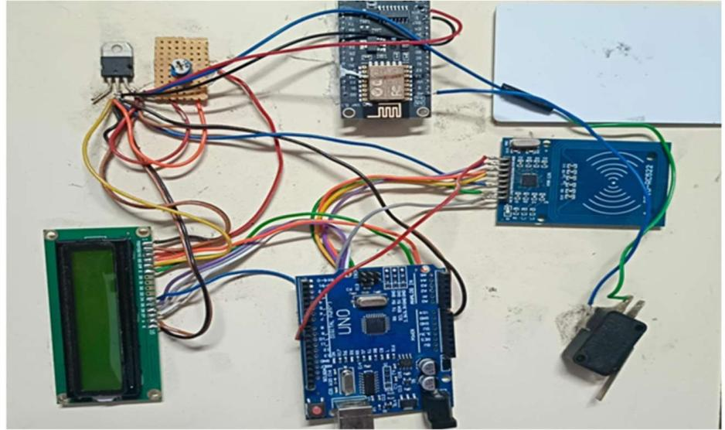

The hardware setup for the Truck Overload Monitoring and Notification System integrates sensing, processing, display, and communication modules into a single working prototype. The core control is handled by an Arduino Uno, which receives data from the connected sensors and modules. A load cell sends weight signals to the microcontroller through an HX711 amplifier.An LCD display is used to show the measured weight and system status.For communication and alert functions, the system includes an ESP8266 Wi-Fi module, which enables data transmission or notification features. An RFID module is included for vehicle identification or access verification, and a micro limit switch is used to detect physical activation or weight platform movement.A voltage regulator and mini power board ensure stable power supply to all modules.

